MODULE 4 – INTRODUCTION TO DBMS

LAB EXERCISES

10. Transaction Control Language – TCL
Lab 1.
Insert a few rows into the courses table and use COMMIT to save the changes.
Ans.
1. INSERT INTO courses (course_name, course_duration) VALUES ('Data Science', '3 year'),
('Artifical Intelligence', '2 year'), ('cyber security', '5 year');
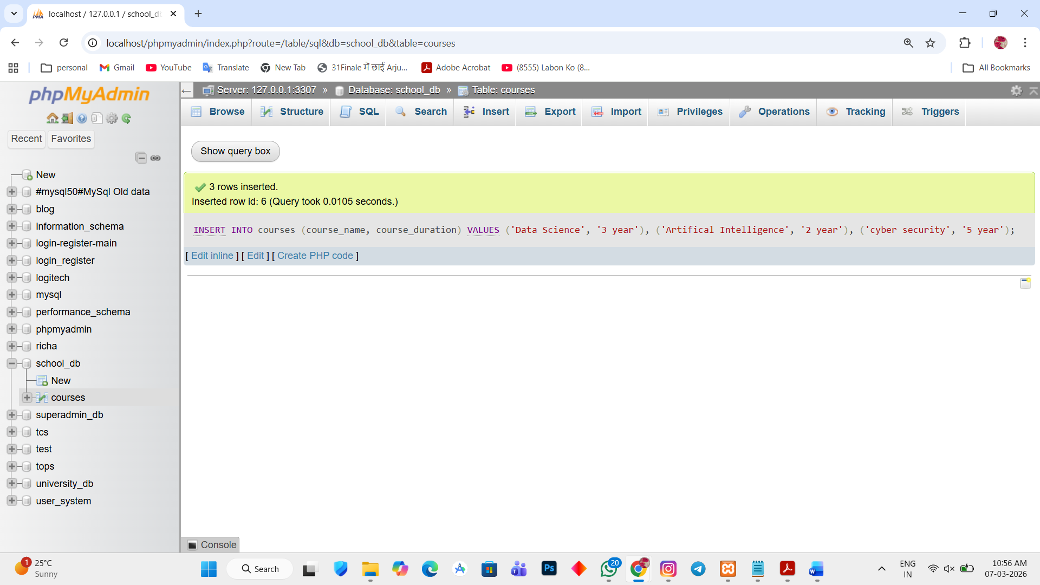

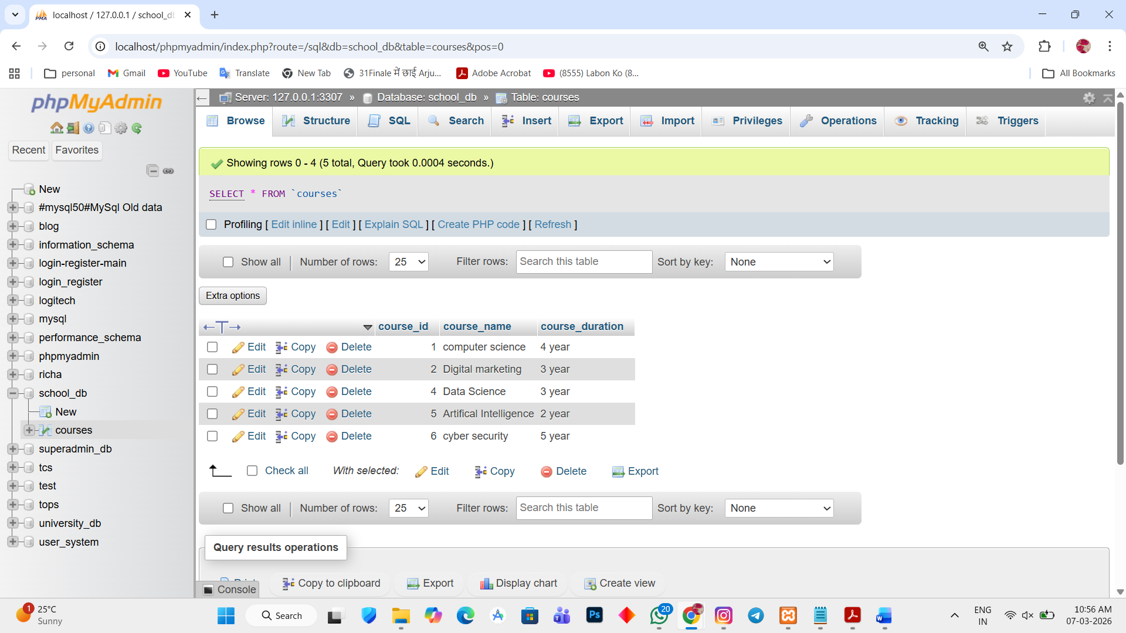

Lab 2.
Insert additional rows, then use ROLLBACK to undo the last insert operation.
Ans.
1. START TRANSACTION;
INSERT INTO courses(course_name, course_duration) VALUES ('Web development', '1 year'), ('Cloud Computing', '2 year');
ROLLBACK;
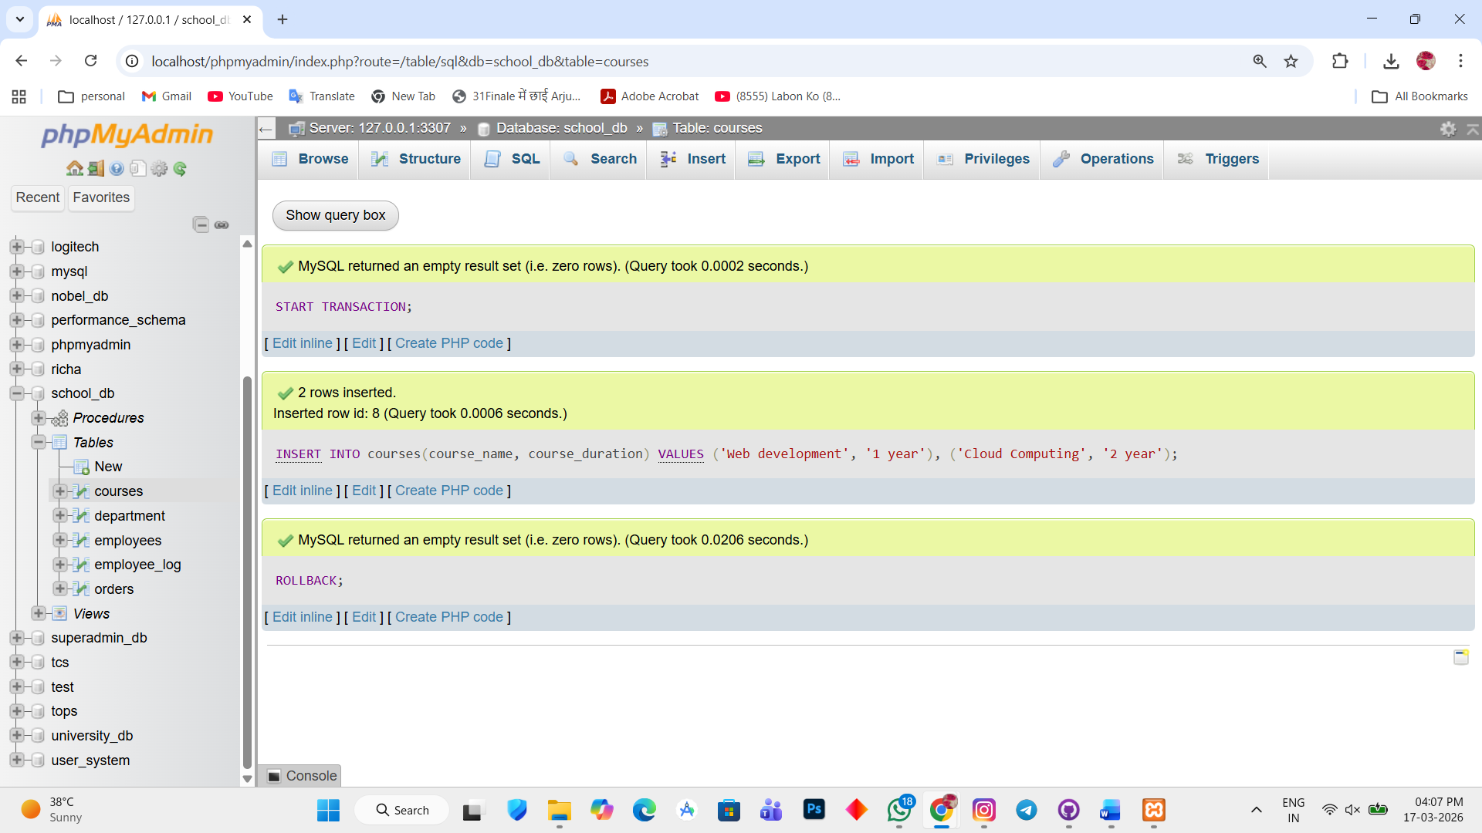

Lab 3.
Create a SAVEPOINT before updating the courses table, and use it to roll back specific changes.
Ans.
1. START TRANSACTION;
SAVEPOINT before_update;
UPDATE courses SET course_name = 'Data Science';
ROLLBACK TO before_update;
COMMIT;
